Nelson International Inc
6310 East Virginia Beach Blvd
NORFOLK, VA 23502

About Nelson International In

Nelson International, Incorporated was formed in 1989 by a group of experienced professionals frustrated with the service trend of the large multi-office customs broker and freight forwarder firms. Primarily at issue were two basic fundamental differences on (1) the quality of services and (2) the conflict of interest brought on by an inclination to become the carrier as well as being the freight forwarder.

For more information please visit:
http://www.cbp.gov/xp/cgov/trade/cargo_security/ctpat/security_criteria/sec_criteria_foreign_mfc/foreign_mfc_security_criteria.xml

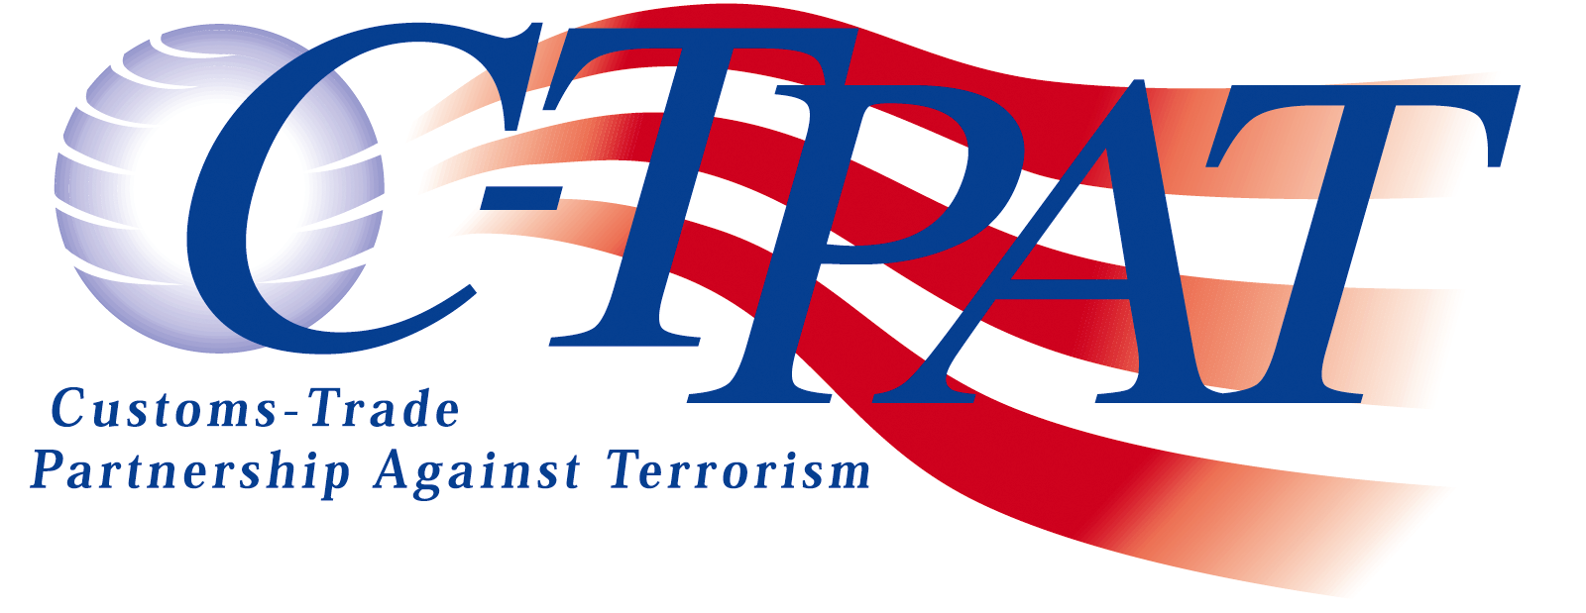
What is C-TPAT?
C-TPAT is a voluntary government-business initiative established to help build cooperative relationships intended to strengthen and improve international supply chain and US border security. Through the initiative, US Customs and Border protection is asking businesses to ensure the integrity of their security practices, communicate and verify the security guidelines of their supply chain business partners.

What are the benefits of C-TPAT?
Participation in C-TPAT will offer overall security benefits throughout the supply chain as well as US Customs & Border protection benefits:
- Reduced number of CBP inspections (reduced border delay times)
- Priority processing of CBP inspections
- Assignment of C-TPAT Supply Chain Specialist
- Eligibility for CBP Importer Self Assessment program
- Eligibility to attend C-TPAT supply chain security training seminars

Nelson International Inc
6310 East Virginia Beach Blvd.
Norfolk, VA 23502
Phone: 757-461-8111 Fax: 757-461-8077
Email: beniii@nelsonint.com
WE HIGHLY RECOMMEND THAT ALL OF OUR CLIENTS VISIT OUR WEBSITE WWW.NELSONINT.COM/CC-TPAT/
THER IS IMPORTANT INFORMATION ABOUT THE
C-TPAT INITIATIVE!

US Customs and Border Protection (US CBP) has efficiently been decreasing the threat of terrorism over the previous years. We are excited to announce that Nelson International Inc joined the war against terrorism by joining C-TPAT program. C-TPAT is a joint initiative between the US CBP and businesses to improve the security of the supply chain. Successfully securing the borders of the USA requires the cooperation of foreign and domestic business partners.

At Nelson International Inc we are committed to ensuring that our business partners are using secure practices throughout the supply chain.

We ask for you assistance in completing the following Security Assessment Survey about your company’s security measures. After completing the Security Assessment, we prefer you to email the survey to beniii@nelsonint.com. If you do not have the availability to email the survey back, please mail or fax to 6310 East Virginia Beach Blvd. Norfolk, VA 23502.
FAX 757-461-8111

We appreciate your cooperation.

C-TPAT Status
Are you C-TPAT Certified?
- Yes we are accepted, Our SVI# is:

_______________________________________
If you are C-TPAT Certified you may send us you SVI Token to beniii@nelsonint.com– you do not need to continue filling out this survey.

- Our application is in progress
- Applied: not certified
- We plan to participate in the near future
- No, we do not plan to participate because:

________________________________________

Do you currently participate in any other domestic or foreign programs?
- YES (Please list)_______________________
- NO

Please Check Yes or No for the following questions.

Access Controls and Employee Procedures
1. Is there a visitor access system in place?
2. Are visitors required to provide ID and sign in before entering facilities?
3. Are visitors/employees allowed to park in or
adjacent to cargo handling areas?
4. Are visitors issued a visitor ID?
5. Are staff required to wear company ID?
6. Are new staff subject to an application, interview, background check & negative drug test?
7. Are procedures in place to remove company property from those terminated?
8. Is staff trained in Security and Threat awareness?
9. Are random periodic security audits conducted?
10. Are procedures in place to change and remove unauthorized persons?

Physical Security & Cargo Handling
11. Is an alarm system set for unlawful entry after hours?
12. Is cargo stored outside of the building at the facility?
12a. Is a fence or surveillance system in place to maintain cargo security?
13. Are doors, windows, and gates secured with locks?
14. Are adequate lighting levels maintained at facility?

Business Partner Selection
15. Are written and verifiable processes in place for selecting business partners?
16. Are all potential available supply chain partners considered when seeking new partners?
17. Are surveys sent to evaluate partner security?
18. Do you maintain records of security survey results?
19. Do you record partner SVI information for review?
20. Are visits to partner locations conducted to verify secure processes?

Customer Screening
21. Are procedures in place to screen customers for validity, ability to meet contractual requirements, financial soundness, and the ability to identify and
correct security deficiencies as needed?
22. Do you use a risk based screening method for prospective customers?

Yes No
 
 

 
 
 
 
    
 
 
 

Yes No
 
 

 

 

 

Yes No
 

 
 
 

 

 

Yes No
 

 

 

    

IT Systems & Electronic Data Interchange
23. Are policies and procedures in place to protect IT systems?
24. Are employees trained in IT security procedures?
25. Are employees assigned and restricted to a user account that is password protected?
26. Are employees required to change passwords periodically?
27. Are passwords required to be complex containing letters, numbers, or symbols?
28. Are employees aware that company email and internal communications is confidential?
29. Are your servers and infrastructure password protected?
30. Are IT files/systems frequently backed up?
31. Are virus & firewall protection installed on all systems?
32. Are procedures in place to protect the integrity of all information used in the clearance of cargo and protect it from errors?
33. Is access to the EDI systems safeguarded?
34. Are periodic audits of data conducted to ensure the safety of the EDI system?

Yes No
 
 

 
 

 

 
    

 

 

 

 

 

 

    

Validity Statement
I, hereby, certify that the information given by me in this survey is true and correct to the best of my knowledge. Should significant changes in our security procedures occur, we will provide Nelson International Inc notification in writing of the changes.

Signature

Company

Full Name

Title Date

Please send via email to: beniii@nelsonint.com

